Pick Cases to Pallet – Insert cases by range
it is possible to add this additional function to the 'Pack Cases to Pallets' module. As to reduce the time-taken for packing, we should have this additional function called 'Insert case# range' as shown in the print-screen below.
Using the below as the example, we should be able to add the case# 1 to case# 21 after clicking on the tab. With this function, we are still able to pack the correct case# into the pallet even if there's any jumped or skipped of case#. With current practice, we are unable to save this pallet if there's any invalid case# or case not packed.

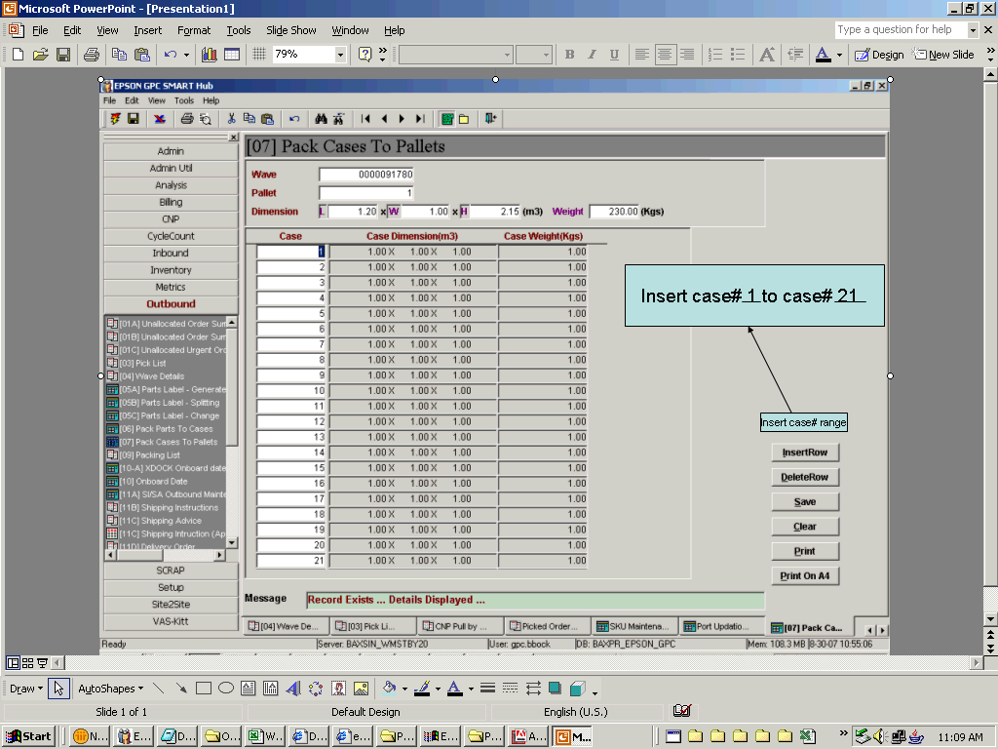

Regards,
Ben Bock Chwee Maw
Logistics Officer
Epson GPC Program
Schenker Singapore (Pte) Ltd,

